How to Use Google Recaptcha :

1. Go to <https://www.google.com/recaptcha/intro/index.html>
2. Click on “Get Recaptcha” top right corner (Log on to your google account)
3. You will be redirected to a page that looks like

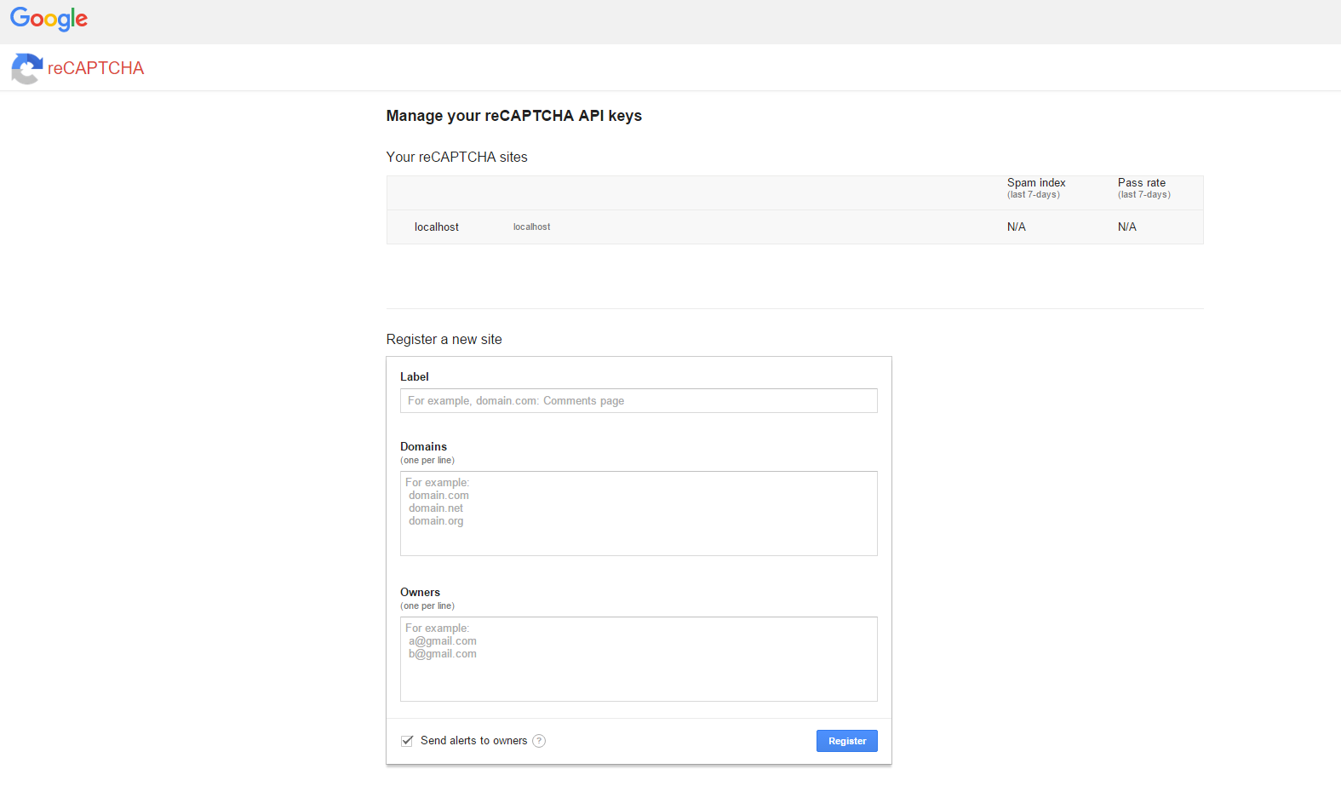

Register your website on this page and specify your gmail id.

You can specify localhost.

Click on register, after you have filled out all the fields.

1. Next you will be redirected to a page that looks like this

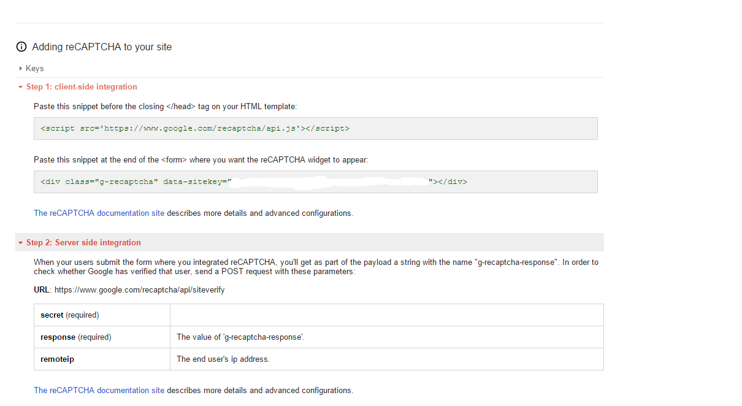

Copy the Step 1 part into your Front end page.

The <div> part inside your form.

After doing this you can see the captcha box inside your form. But to validate it you will have to follow the step 2 instructions.

1. Finally, to validate your Captcha we will use the step 2 content mentioned in the above picture.

To send a post request we will use <https://github.com/propan/clj-recaptcha>

Import the above mentioned package in your project.clj . And follow the instructions on the Github page. Finally you can validate your captcha like this

(c/verify "your-private-key" "response" :remote-ip "127.0.0.1")